Laboratory work No. 15
Application programs are intended to provide application of an ADP equipment in different fields of activity of the person. In addition to creation of new software products developers of application programs waste great efforts to enhancement and upgrade of popular systems, creation of their new versions. New versions, as a rule, support old, saving an eligibility, and include a basic minimum (standard) of opportunities.
One of possible options of classification of the software (S) making the application software (AS) is reflected in fig.1. As well as almost any classification given on a figure isn't unique. In it even not all types of application programs are provided. Nevertheless, use of classification is useful for creation of general idea about PPO.
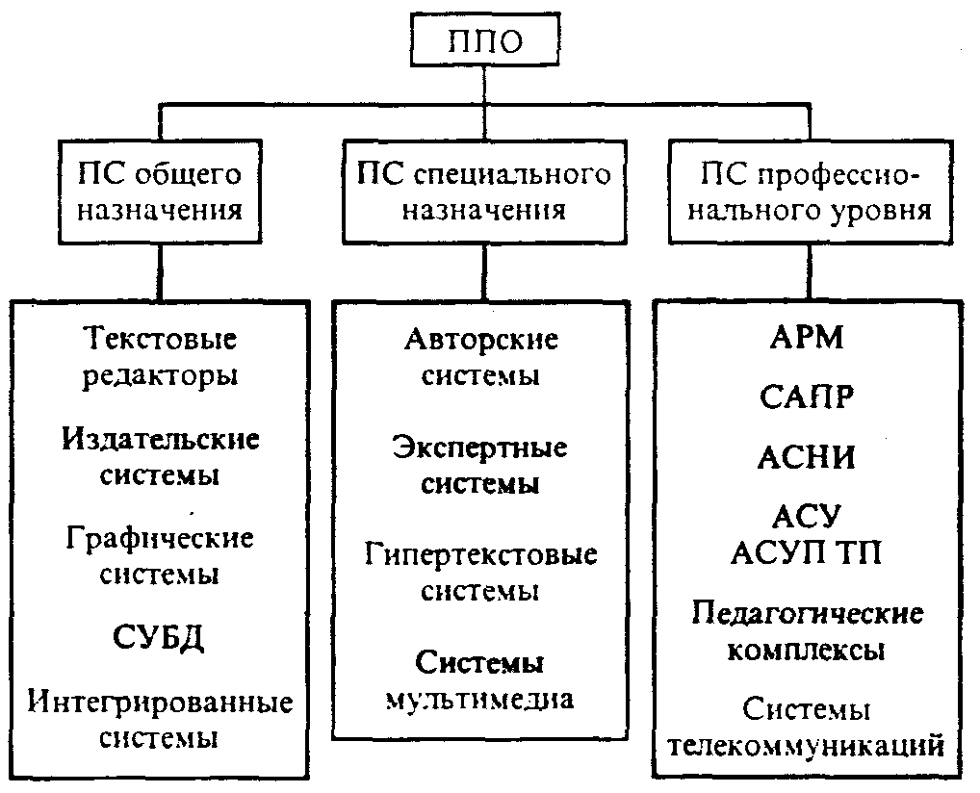
Fig. 1. Classification of the applied software

SOFTWARE OF THE PROFESSIONAL GRADE
Each application program of this group are guided by rather narrow data domain, but penetrates into it most deeply. So ASNI - automated systems of scientific research function, each of which "is bound" to a certain field of science, a CAD - automated design engineering systems, each of which also works in narrow area, ACS - automated control systems (which in 60 - 70 years thousands were developed).
At last, once again we will emphasize not only conditionality of the classification offered above, but also existence of intersections. So, each specific expert system can quite be carried to PPO of the professional grade; the principle of the hypertext is realized in a number of authoring systems, etc.
Installation and setup of application programs
The application software (software) is intended for the decision of certain standard tasks, inevitably originating in case of informatization of your company. Document flow, accounting activities, use of network resources, communications, operation with a graphics or databases — all programs solving these problems belong to the general class of an application software.
As a rule, the standardized application software which is issued in the form of the application program packages integrated by the form solvable tasks is suitable for the decision of similar tasks. Depending on your needs and the budget selected for these purposes, the functionality and cost of such packets can significantly differ as well as complexity of setup of the selected programs. To choose the necessary application software in the modern conditions — rather complex challenge for the nonprofessional in IT to the sphere. Installation and setup of application programs — as a rule too rather complex challenge, owing to their variety and different approach to programming used by vendors of an application software.
Our company has many ready configurations of packets of an application software which in most cases will be suitable for your company. In case of specific tasks which you need to solve we are always ready to make, set and set up the application program package which is best meeting needs of your company.
Sometimes the reverse situation when there is no possibility of a choice of application programs meets, but there is a need to set, set up and force to work strictly certain software — for example in a case bank clients. The most frequent problem in case of installation and setup of a "stimulated" application software is the task of compatibility with already installed programs. Our company has vast experience of the successful decision of such tasks. If for example at you two bank client which certificates clash with each other and installation be made on one computer is just one of problems with which solution you can be helped by our experts.
Now typical packets of an application software with which we usually work include:
• The office software – MS Office, OpenOffice
• Accounting a software – 1C, Bank clients, the Internet reporting
• The system software – antiviruses, archivers
• Network a software – clients of mail, ICQ, Internet browsers
• Graphic a software – Adobe Photoshop, Corel Draw
The list of packets of an application software can be continued almost infinitely. The appropriate application software is already developed for the majority of problems which are solved anyway by many companies. Therefore the simplest option will be to address our experts for receiving consultation in your problem, most likely we will be able to offer you already ready or requiring the minimum finishing decision satisfying to your requests to an application program package.

